**Course**: PH3250

**Assignment**: CITI training

**Due**: See syllabus for due date

**Instructions**: Follow the steps below to complete the assignment.

**Grading rubric**: This assignment is worth a total of 50 points and will be graded on the following criteria:

|  |  |  |
| --- | --- | --- |
|  | Unacceptable | Excellent |
| CITI | The incorrect CITI training course was passed and/or the student did not upload the certificate online by the due date.  (0 points) | The correct CITI training course was passed and the student uploaded the certificate online by the due date.  (50 points) |

1. Click this link: <https://about.citiprogram.org/en/homepage/> to go to CITI’s homepage. Then, click “register” to create a new account.

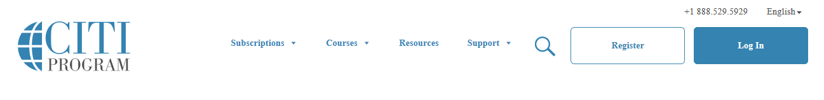

2. Type “Appalachian State University” here, click “I AGREE”, click “Continue to Step 2”

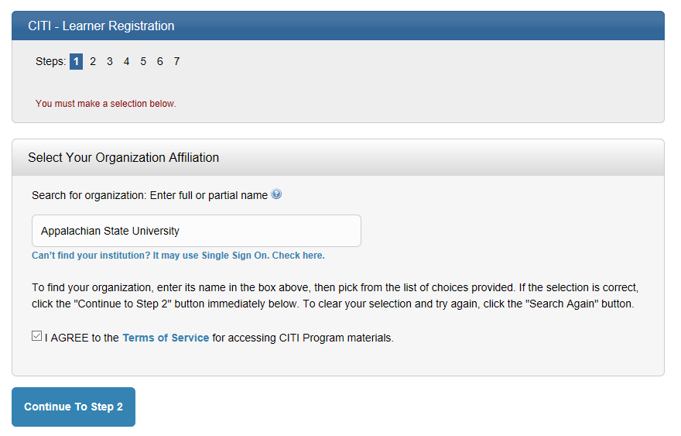

3. Type your real first name (no nicknames, i.e., “funky skunk”), your real last name, and your App State e-mail address (it must be your App State e-mail in order for this to register with IRB office on campus), click “Continue to Step 3”

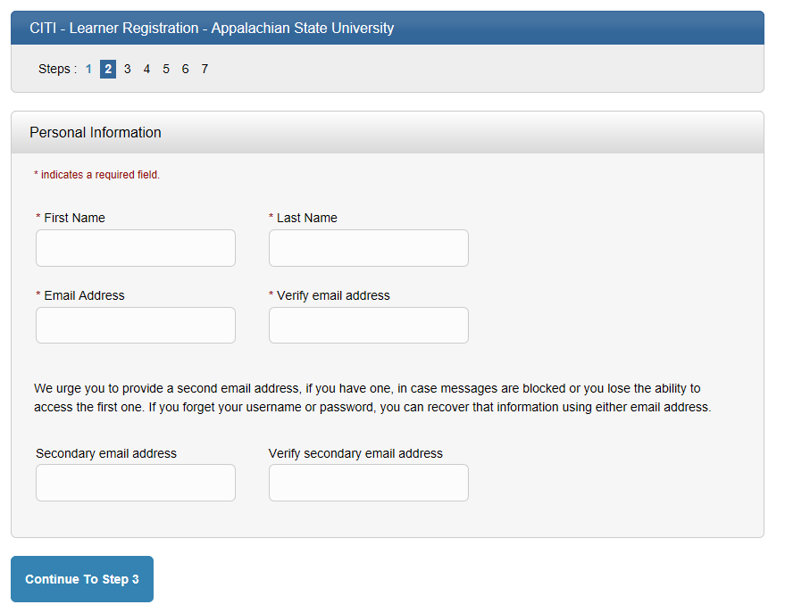

4. Create a user name, password, security question, and security answer. Click “Continue to Step 4”

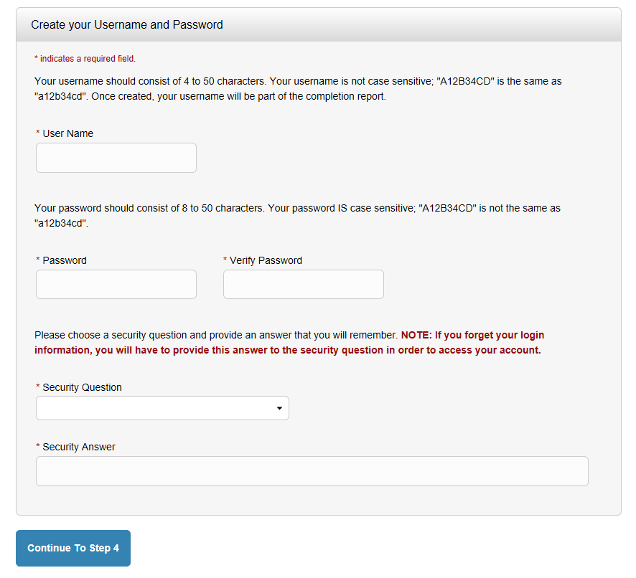

5. Type “United States” and click “Continue to Step 5”

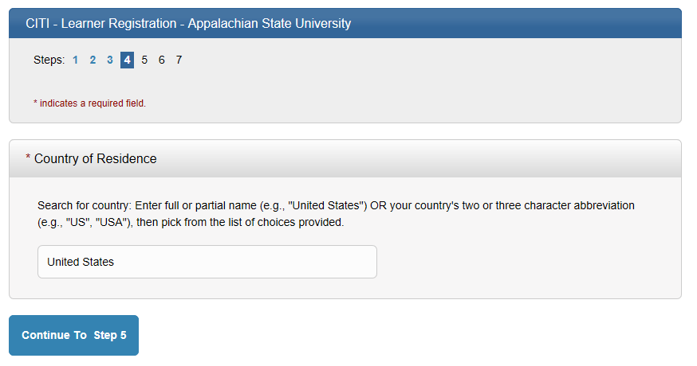

6. Click “No”

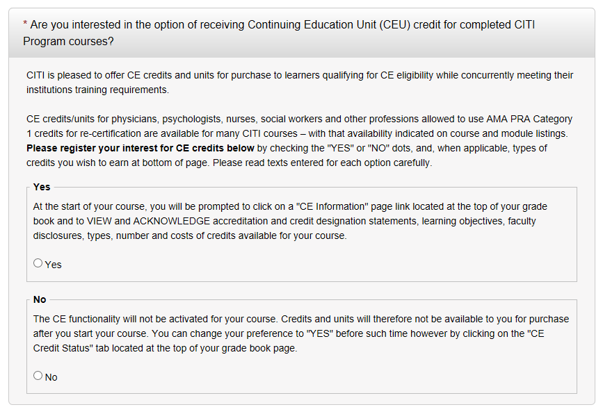

This is up to you. If you want to surveyed, click yes. If not, click no. Then click “Continue to Step 6”

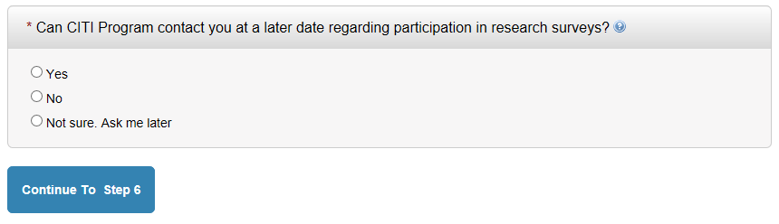

7. Choose your language preference, type your App State e-mail, your gender, and your highest degree. Skip the employee number and department.

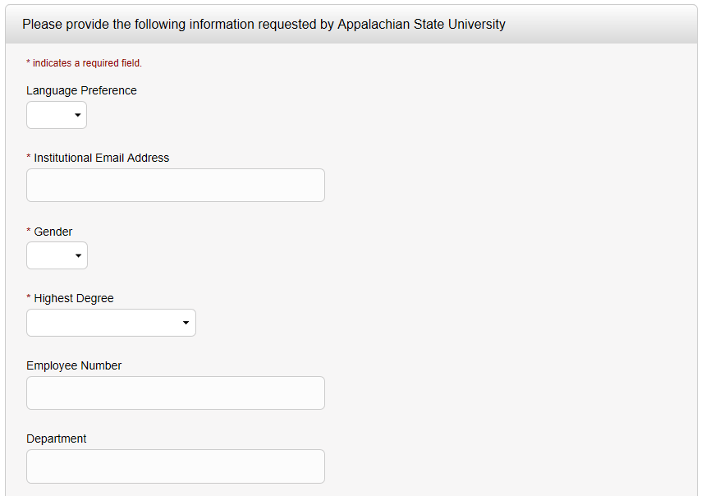

8. For the “role in research” choose “student researcher – undergraduate.” You can skip the address, city, state, zip code, and country

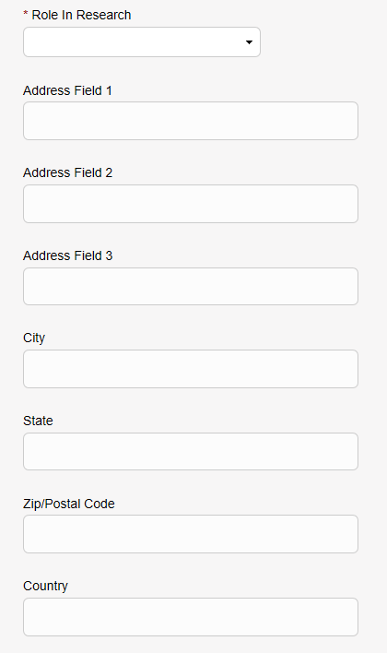

9. Enter your cell phone (since you probably do not have an office phone) and choose the “Basic Human Subjects – Social & Behavioral Focus.” Click “Continue to Step 7”

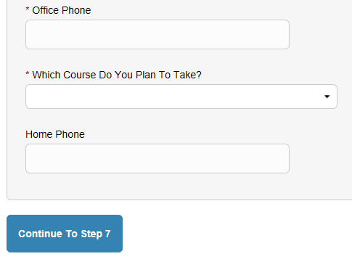

10. Click the “Human Subjects Research” option. Click “Next”

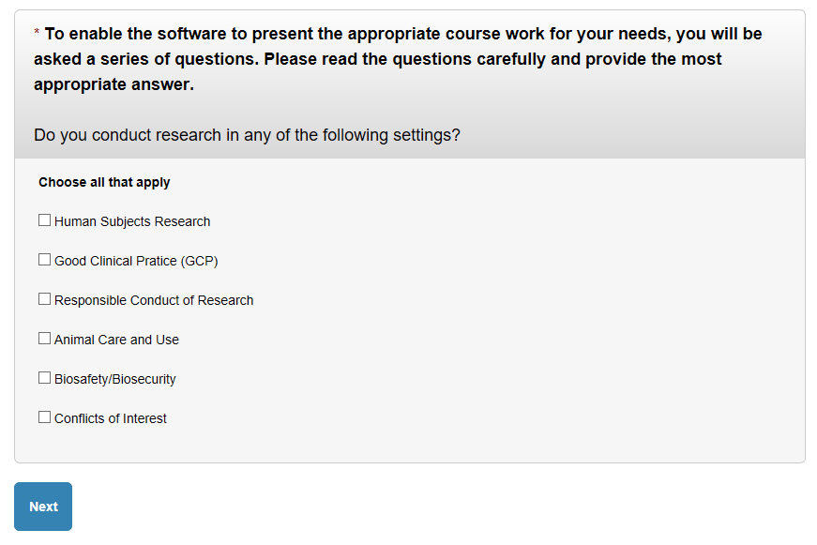

11. Click “NO.” Click “Next”

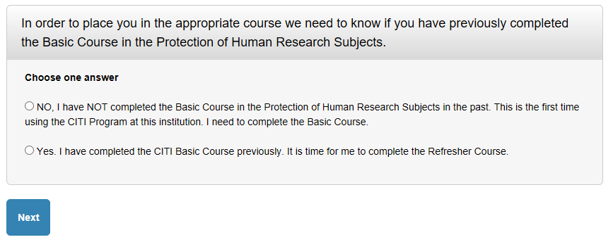

12. Click “Social & Behavioral Research Investigators.” Click “Next”

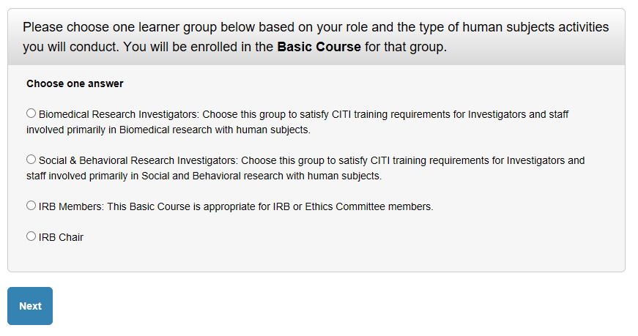

13. Click “Finalize Registration”

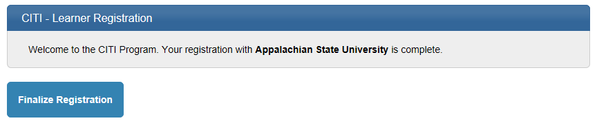

14. Click on “Social/Behavioral Research Course”

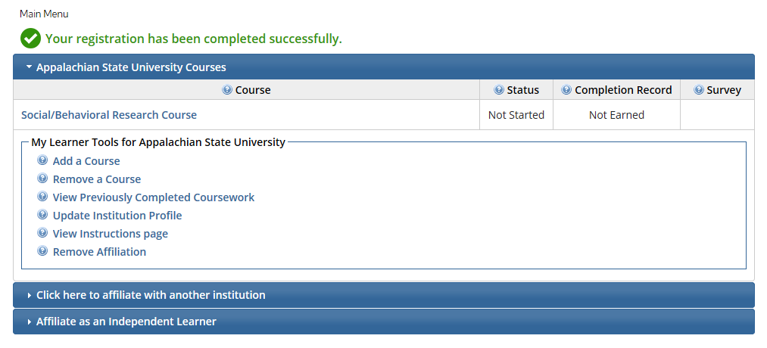

15. Click on “Complete the integrity assurance statement before beginning the course”

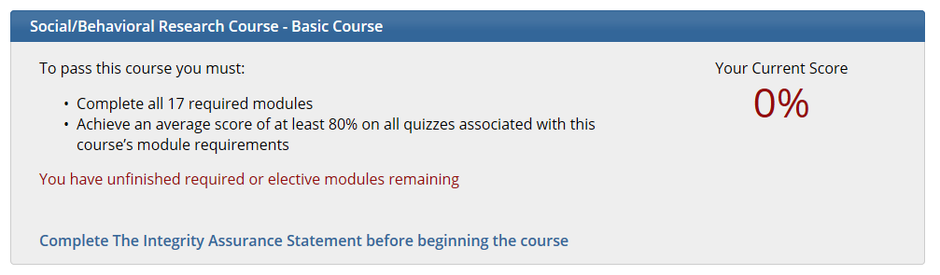

16. Read the terms of service and then click “I AGREE” and click “submit”

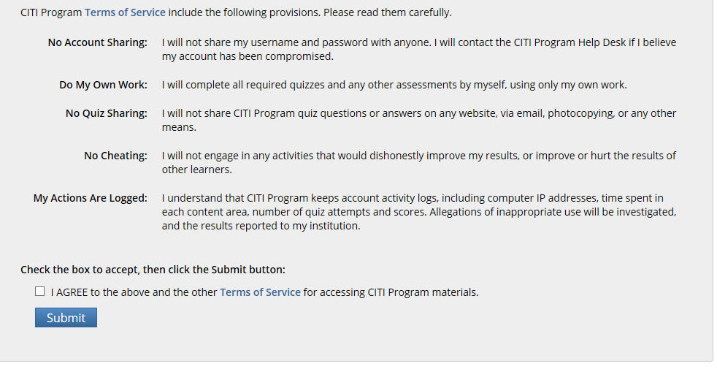

17. Click on the first incomplete required module in the course (my list looks slightly different from what yours will be). After you read the module, take the quiz. If you pass the quiz, the date you completed the quiz and your score will be listed. You need to get an average of 80% on all modules. If you do not, you can keep taking it until you pass

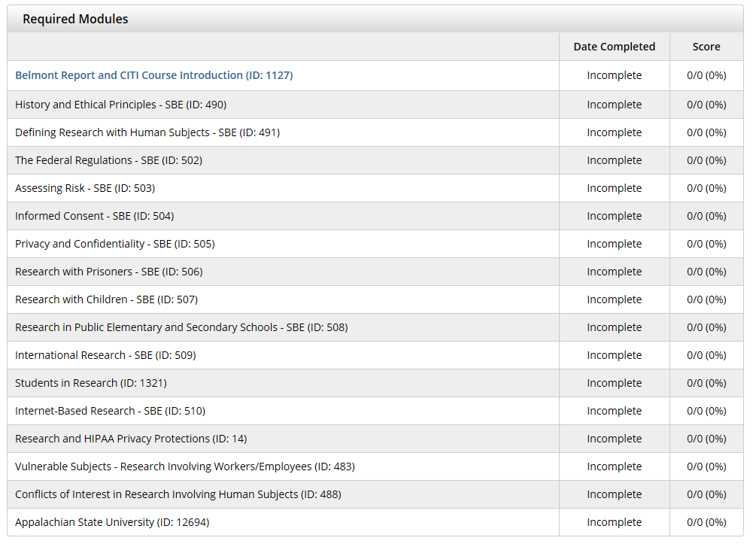

18. After submitting your quiz answers, you will see these options at the bottom of the quiz. If you did well on the quiz, you can take the next module. If you did poor on the quiz, you can view the module again and re-take the quiz.

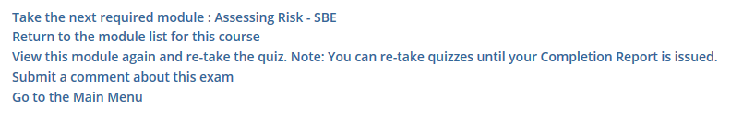

19. After completing each module, you will see that the “Appalachian State University” module will be your last module and that you do not need to complete a quiz. Just click “View Post-Course Completion Options”

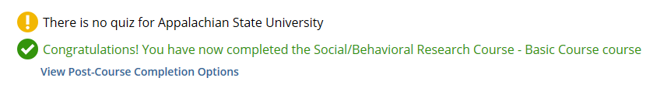

20. Then, click on “Access your Completion Records”

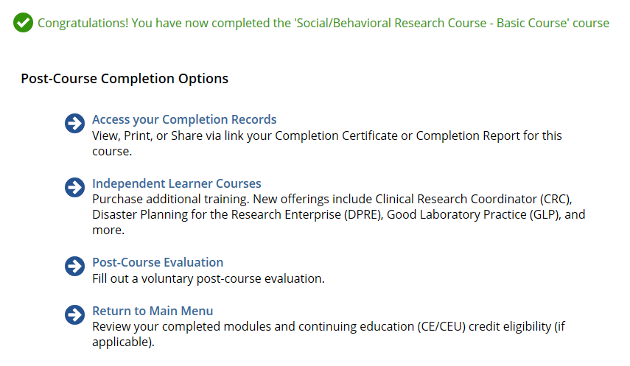

21. Click on the second link to get your certificate “diploma.” Save the diploma and submit it online for your grade. If you have trouble saving the diploma, please just take a screen shot of this screen (the same as you see below) and save it to a Word document and submit it online.

